Introduction
Humans constantly control and manage their resources to remain healthy and functional. To thrive, we need enough food and water, but also inherit and develop abstract resource needs like social contact, money, and recreational time. Whereas one action may replenish one of these resource budgets (RB), it simultaneously depletes others. As living organisms, we act in an ever-changing world and balance those resources by estimating and evaluating the subjective value of actions, driven by needs and rewarded by satisfaction. An action is evaluated by comparing between the relative overall state before and after the action across all RBs. Evolutionarily, the resulting valanced experience indicates a change in perceived subjective fitness, one’s subjective sense of success in this world (Hesp et al., 2020).
Resource management is a hierarchical process that does not require conscious experience. For lower order bodily resource management, the neuroscientist Barrett (2017) coined the term body budgeting regions, encompassing brain areas that predict and prepare RB needs. These regions ensure that our organism is predictively prepared. These predictions are afterwards compared to the actual RB necessities and predictive errors processed to improve future estimations. The result is signalled as interoceptive sensation (Barrett, 2016). Those sensations cumulate to higher order affective responses and emotions which function as bottom-up allostatic signals. Frijda and Swagerman (1987) describe the role and processing of higher-level emerging cognition and emotions. Emotions and feelings primarily aid an intuitive concern prioritisation. Objects and possible goals are constantly revaluated in terms of their concern relevance. Emotions and feelings facilitate situational appraisal (Frijda, 2016). Together, Barrett, Frijda and Swagerman show how we compute a valanced indicator for the questions “Will it be worth it?” and retrospectively “Was it worth it?”, which we then act upon. Mood disorders like depression or anhedonia could indicate a biased evaluation of concern relevance priorities (Barrett, 2017, Stephan et al., 2016). By over- or underemphasizing RB needs, actions are more readily judged as bad or worthless, as they are interpreted as not beneficial for ones esteemed RBs. In this work, we explore the potential pathways that can lead to such imbalances in mood disorders.
Treating entities as managing resources is traditionally part of disciplines like ecology and economy. Similarly, brain sciences have used this framework and describe brain processes as management of resources like energy and oxygen (Kleckner et al., 2017). Affectively, evaluation takes place through dopaminergic and endospheric pathways. More subtle alterations are managed in form of allostatic processes that combine evaluation and alteration, for example by orchestrating homeostatic feedback loops to achieve overall balances in brain temperature. In psychology, the concept of resource accumulation and management is closely related to the affective experiences of motivation and need. Motivational theories like Maslow’s hierarchy allow us to model affective drive and reasoning, which reveal possible causes of maladaptive affective behaviour and pose promising targets for clinical interventions (Maslow, 1943).
Formalising the scope of resources proves difficult due to their domain generality. We infer and conceptualise resources by any sensory, semantic, or counterfactual modality, as they manifest in equally diverse ways. So far, this variety prevented a quantifiable description of any kind of resources, as they lack non-arbitrary ways to be converted into a universal scale (Hesp et al., 2021). Generalised concepts are less prone to biased conclusions and easier applied by researchers of other fields (Sajid et al., 2021, Yarkoni, 2022). Our goal is to condense resources to their essential affectively motivational and functional properties to create comprehensive models which can be numerically analysed and used in insightful simulations, as well as experimentally verified.
In this paper, we are using the active inference framework, that views humans and other living organisms as predictively acting agents, trying to infer the states of the world. To increase their subjective (felt) fitness, agents try to occupy states, such as ideal resource levels). By doing so, we hope to go beyond more qualitative theories like Maslow in describing drive and create a quantitative model which can be numerically analysed. We are going to show how a person can derive a forecasted valanced evaluation of an action by solving hierarchical Bayesian networks through active inference. By computing various resources and their relative value changes from the phenotypical (subjectively idiosyncratic) ideal state, agents can derive affectively valanced judgments. We are first going to describe this approach of action evaluation. We are then going to simulate an agent that chooses between future actions by considering the predicted fluctuations of resources which influence its affective self-image. Lastly, we are going to examine agents that fail to preserve their level of fitness. We will draw parallels between their behaviour and individuals that suffer from motivational disorders such as anhedonia, anorexia and social anxiety. We thereby hope to show an ontologically alternative approach to affectively valanced internal and external evaluation as depending on abstract organismic RBs and discuss its implications and benefits.

Methods

Active Inference
We are using the hierarchical deep Bayesian model as described by Hesp and colleagues (2021) which is derived from the active inference framework. The agent is generalized as a system of nested Markov blankets whose interaction with the world is conceptualised as partially observed Markov decision processes. This means that across discrete states, a probability distribution is adjusted to approximate the real world, the generated (hidden, unobserved) states (s), by probing input (sensory outcome, (o), which is observed). Additionally, our agent counterfactually extrapolates itself, perceiving itself generating and probing the world across future time points, as proposed by Friston and colleagues (2021). It estimates its own changes in states, as well as affectively valanced reactions to those imagined changes in observations and actions.
This approach is suitable to compute RBs, as it generalises both material needs, such as food and abstract needs, like social status. The agent’s internal structure and believe is completely isolated from the external world. Only through a sensory intermitted layer, the external world indirectly interacts with the agent’s internal world. The agent always needs to compute and interpret the input to derive a model of the external world it cannot access. The agent prefers some sensations over others, leading it to act on the external world to promote favoured sensations. This summarises the rationale behind the name active inference, as the agent actively tries to infer states of the world, namely the ones ideal to itself. While there are evolutionarily preferred states, such as preferred temperatures, we can assume subjectively constructed states, for example the desire to infer the state of winning a sports tournament.

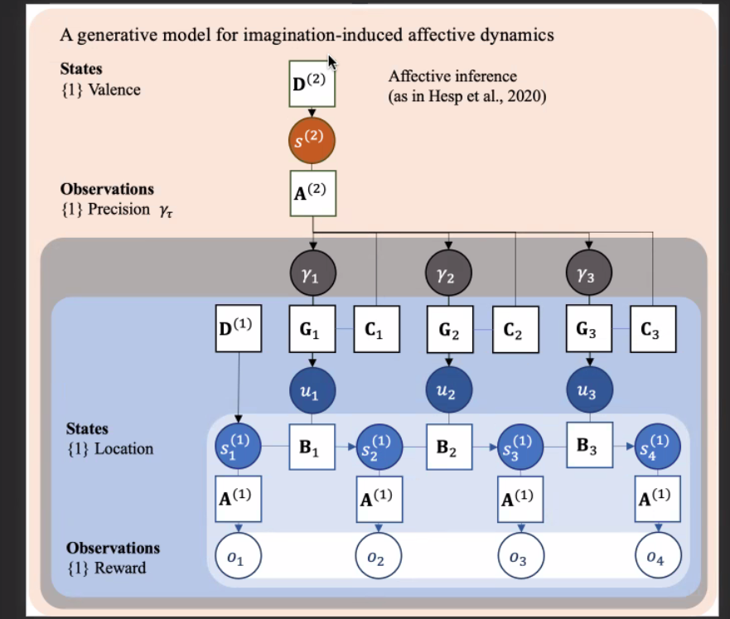
Figure 1: The generative model used to model the resource management of the agent.

At the first level of “direct perception”, an observation o prompts the agent to infer a hidden state s, causing the observation, shown by the likelihood map A. Prior believes $D$ about these hidden states are updated with o to derive s. On a second level of “anticipation”, the agent additionally expects state transitions of s over time, as described by B, which in addition to o informs s. At the third “action” level, the transition matrices B are influenced by policies (actions) u. Whereas the agent was previously only able to perceive and predict the processes of the world, it can now actively influence what it wants to observe and how to react to the environment.
To determine which action to take, the agent considers each action's influence on its expected free energy G (Hesp et al., 2021). Actions that reduce the expected free energy (which means to increase evidence of phenotypically beneficial states of the world for the agent) are preferred. Together with a baseline prior E (omitted in Fig. 1) across potential policies u, G determines the beliefs of the agent about possible policies. One factor that influences G in the complete model of active inference is the perceptual ambiguity F (omitted in Fig. 1). It reflects how reliable the effects of policies can be predicted and will not be considered in our model. Additionally, G is determined by the phenotype-congruent (agent-specific) preferences of the agent C, which quantifies each policy in terms of risk. Risk is the difference between expected outcomes of policies and preferred outcomes. Importantly, we determine RBs to be expressed in C, and allow it to change the agent's preferences accordingly.
On the fourth layer of implicit meta-cognition, γ reflects how reliable the policies u are estimated and pursuit to affect G. It is a measure of subjective fitness and confidence in the agent’s action model. This holds, since the ability to effectively influence G affords reliable estimations of the effects of the agent's actions, based on the hidden states of the world. It is quantified between time points as affective charge (AC), leading to a positive charge if the chosen policy causes a better-than-expected reduction in G and therefore a more favourable world. Conversely, a negative charge builds up, if the action model fails to reduce G as much as previously expected.

Results
We show in this section the simulated results of the previously described parameters of an agent that chooses between 4 locations of varying effect on resource levels. The resources are energy and being nurtured, (i.e. combating exhaustion and hunger). Those resources must be sacrificed to observe affectively rewarding values. The exact values are given in Table 1. To receive the overall preference of the agent at each time point, we sum over the preferences according to reward, energy, and hunger. The reward evaluation directly contributes to the observation preferences (C1), while both energy and hunger are also determined by their current level. If energy or hunger are at their preferred level, they weigh less into the pooled preferences. Conversely, if their levels deviate strongly, they are more strongly considered to promote its behavioural reinstatement through action. We are looking at 2000 consecutive steps that are performed by an agent per trial.

 | o1[0] | o1[1] | o1[2] | o1[3]
Reward (C0) | 0 | 1 | 2 | -3
Energy (C1) | 2 | -1 | -3 | -3
Hunger (C1) | -2 | 4 | 8 | -2
Table 1: The effects of occupying one of 4 states. o1[0] resembles a neutral recovering state: The agent rests and increases its energy and reduces its hunger without effect on reward. Both o1[1] and o1[2] are experienced as rewarding, though each of the states reduces energy and increases hunger. o1[3] was created to be inferior to the other positions (reduces reward, reduces energy, while only restoring as much hunger as o1[0]).

Looking at the given transition matrices B for each resource, the agent assumes to remain in its current affective state with a probability to transition to another affective state. The agent assumes to stay non-exhausted while being non-exhausted over time, while becoming non-exhausted in a state of exhaustion. Similarly, the agent does not assume to become non-hungry while being hungry in its current state, while assuming to get hungry over time while being non-hungry now.
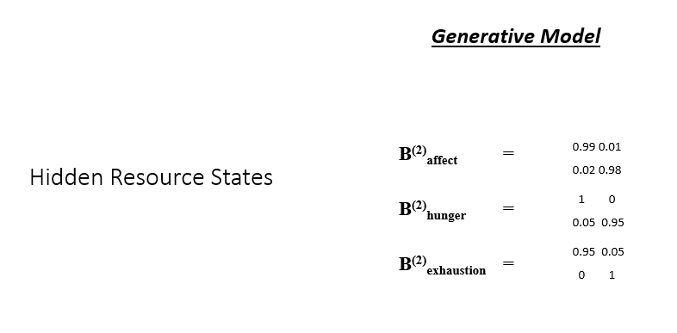
Graph 2: The probabilistic graphical model shows the hidden resource level states, which are either high or low with the respective probability of switching between states over time. Here, the likelihood of transitioning/staying positively affected, hungry or exhausted is on the left side, and its negation on the right. The upper row describes being positively affected, hungry or exhausted now, the lower row its negation.
We are now using a trial of an agent to develop an intuition for its progression across time. discu.
In Figure 2b-d, we see one example of a simulated agent. It shows the preferences for the first, second, and third policy selection of the agent. For u1, the agent shows a preference for the C=1 policy with approximately 80%, C=2 at around 17.5%, and C=0 at around 2.5%. For the following steps, it projects for u2 and u3 to select the C=2 policy. The uncertainty causes C= -3 to be considered more. These results show that the agent switches between the three policies, preferring C=1 as a compromise between resource concerns, at times allowing to seek higher rewards while settling for a lower payoff between exhaustion and hunger. To replenish energy, the agent needs also to occasionally select C=0. C=-3 as not being beneficial is not considered as policy. As Figure 2a suggests, the agent can ensure a fluctuating but stable level of confidence in its action model over time, corresponding to its perceived ability to reduce its free energy.
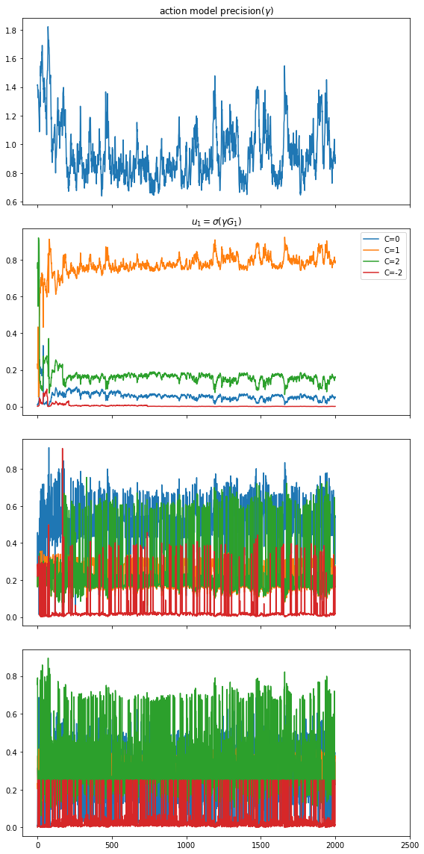
Figure 2: Results of a simulated agent across 2000 consecutive timesteps. a) The perceived precision parameter of the agent across time. Low values indicate that the agent places low certainty in its ability to satisfy its needs through its action, decreasing the weight of its own action preferences. b) The agents preferred action after the previous action. It aims to minimise C1, which is the sum of reward value, the product of effect on hunger and current level of hunger, and the product of exhaustion and the current level of exhaustion. While C=1 is generally preferred there are still sizeable chances to select another policy. The exception can be found in C=-3, which has a close to 0 preference by the agent. c) The second preferred action after the initial preferred action is assumed to have taken place. d) The preferred action u3, the counterfactually preferred action after two previous policies.

In Figure 3, we see a combined depiction of the resource levels of hunger, exhaustion and valence. Here, the agent tends to maximise its exhaustion while only for comparably short periods reducing the descrapency. Similarly, hunger tends to be low with temporary increases. This is due to the different options of C, that value options that reduce energy and increase nurturing higher, which means that the C= 1 and C = 2 options are benefiting the valnce, whereas C= 0 and C= -3 do not.

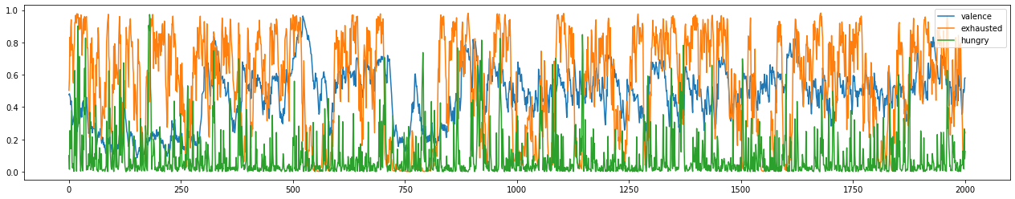
Figure 3: We see the corresponding resource levels of the agent. Whereas the valence of the agent fluctuates in more extended cycles, the exhaustion tends to be high, while the hunger is predominantly low. Since choosing rewarding policies cooccurs with a reduction of hunger and increases in exhaustion, these results suggest that the agent chooses C=0 to reduce exhaustion to then select C=1 and C=2 until exhaustion levels have risen to a point that needs to be relaxed by choosing C=0.

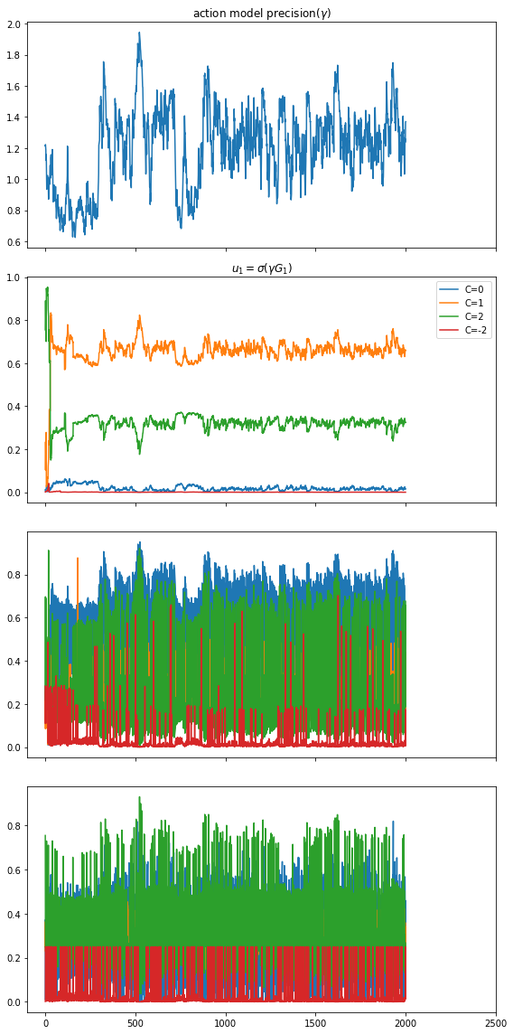
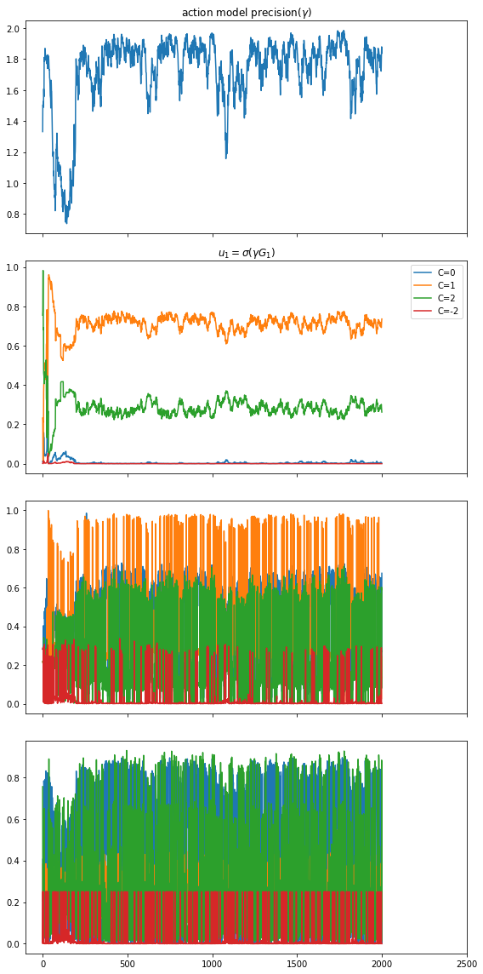
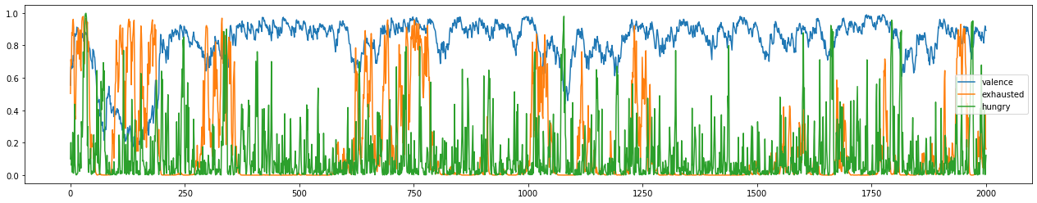
In Figure 3, we see the corresponding resource levels of the agent. Whereas the valence of the agent fluctuates in more extended cycles, the exhaustion tends to be high, while the hunger is predominantly low. Since choosing rewarding policies cooccurs with a reduction of hunger and increases in exhaustion, these results suggest that the agent chooses C=0 to reduce exhaustion to then select C=1 and C=2 until exhaustion levels have risen to a point that needs to be relaxed by choosing C=0.
We show in this section the simulated results of the previously described parameters of an agent that chooses between 4 locations of varying effect on resource levels. The resources are energy and reward. The locations are neutral (0 energy and 0 reward), low intensity (-1 energy and 1 reward), high intensity (-2 energy and 2 reward), and lastly an unfavourable location (-3 energy and -3 reward).
The results in Figure 1 show that the agent fluctuates between preferred locations, whereas the neutral location is favoured predominantly and the unfavourable location the least. Since the agent is not provided with a possibility to actively enhance its energy level, reducing it least is preferred. This can also be seen when monitoring the precision of the action model $gamma$, which is constantly declining as C constantly diverges from its preferred state.
In a second simulation, we provide the model with more clear locations to affect the resource parameters of the agent. We choose a beneficial location (1 energy, 1 reward)

\bibliographystyle{apalike}
\bibliography{references} % see references.bib for bibliography management

\end{document}

